**Creating Azure Blob storage**

In order to prevent Vendor lock-in we are using Azure storage account instead of s3 bucket

Steps :

Creating resource group

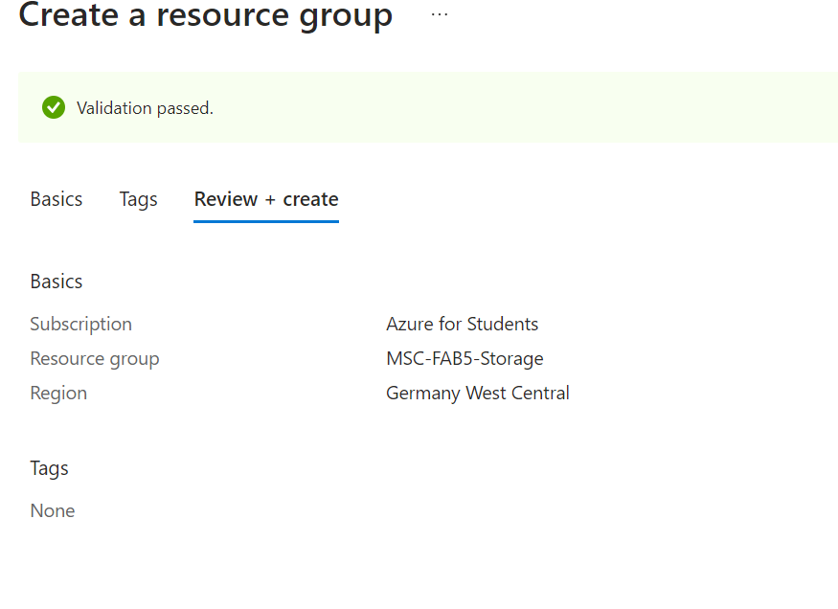

**Create storage Account**:

